Task 1

library(data.table)

library(ggplot2)  
library(ggmosaic)

library(readr)

library(plyr)  
library(dplyr)

filePath = "C:/Users/jerem/Desktop/Quantium/"  
transactionData = fread(paste0(filePath,"QVI_transaction_data.csv"))  
customerData = fread(paste0(filePath,"QVI_purchase_behaviour.csv"))  
###Exploratory data analysis  
  
str(transactionData)

transactionData$DATE <- as.Date(transactionData$DATE, origin = "1899-12-30")  
  
# checking the type of product  
unique(transactionData$PROD_NAME)

productWords <- data.table(unlist(strsplit(unique(transactionData[, PROD_NAME]), "  
")))  
setnames(productWords, 'words')  
## removing digits and special characters  
  
productWords = apply(productWords, 2,function(productWords) gsub("[[:punct:]]", "",gsub("[[:digit:]]", "",gsub("\\g$","",tolower(productWords)))))  
  
##SORT PRODUCT WORDS BY OCCURENCE (NOT DONE YET)  
  
  
##Remove salsa products  
transactionData[, SALSA := grepl("salsa", tolower(PROD_NAME))]  
transactionData = transactionData[SALSA == FALSE, ][, SALSA := NULL]  
  
  
##Summary stats  
summary(transactionData$PROD_NBR)

summary(transactionData$PROD_QTY)

summary(transactionData$TOT_SALES)

#finding and eliminating outlier  
outlier = subset(transactionData, transactionData$PROD_QTY == 200)  
outlier_ID = outlier$LYLTY_CARD_NBR[1]  
outlier_transaction = subset(transactionData, transactionData$LYLTY_CARD_NBR == outlier_ID)  
  
transactionData = transactionData[LYLTY_CARD_NBR != outlier_ID]  
  
#Re-examining transaction Data  
unique_Dates = as.data.frame(unique(transactionData$DATE))  
setnames(unique_Dates, "Dates")  
  
# filling in missing day  
dates <- as.data.frame(seq(as.Date('2018-07-01'), as.Date('2019-06-30'), by = 'days'))  
setnames(dates, "DATE")  
transactions_by_dates = transactionData %>% group_by(DATE) %>% count(DATE)  
Dates_with_missing = merge(transactions_by_dates, dates, by = "DATE", all.y = T)  
  
  
  
  
#### Setting plot themes to format graphs  
theme_set(theme_bw())  
theme_update(plot.title = element_text(hjust = 0.5))  
  
  
#### Plot transactions over time  
ggplot(Dates_with_missing, aes(x = DATE, y = n)) +  
 geom_line() +  
 labs(x = "Day", y = "Number of transactions", title = "Transactions over time") +  
 scale_x_date(breaks = "1 month") +  
 theme(axis.text.x = element_text(angle = 90, vjust = 0.5))

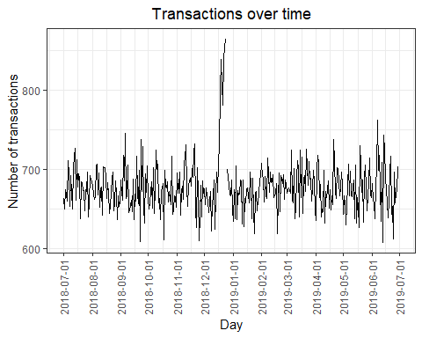

#plotting december  
december = Dates_with_missing %>% filter(DATE < as.Date("2019-01-01"))  
  
december = december %>% filter(DATE > as.Date("2018-11-30") )  
  
  
ggplot(december, aes(x = DATE, y = n)) +  
 geom_line() +  
 labs(x = "Day", y = "Number of transactions", title = "Transactions over time") +  
 scale_x_date(breaks = "1 day") +  
 theme(axis.text.x = element_text(angle = 90, vjust = 0.5))

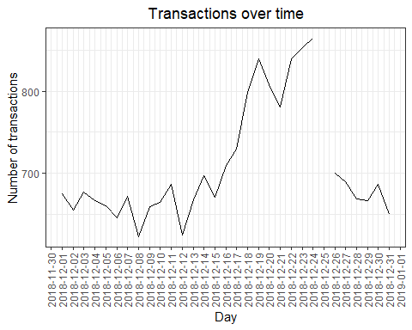

# We can see that the increase in sales occurs in the lead-up to Christmas and that  
# there are zero sales on Christmas day itself. This is due to shops being closed on  
# Christmas day.  
# Now that we are satisfied that the data no longer has outliers, we can move on to  
# creating other features such as brand of chips or pack size from PROD_NAME. We will  
# start with pack size.  
  
# pack size  
transactionData[, PACK_SIZE := parse_number(PROD_NAME)]  
Pack_size = transactionData[, .N, PACK_SIZE][order(PACK_SIZE)]  
#histogram  
  
plot_pack_size = ggplot(data= Pack_size, aes(x=PACK_SIZE, y= N))+  
geom_bar(stat="identity")+  
theme(axis.text.x = element_text(size = 10, angle = 45, hjust = 1))  
plot_pack_size

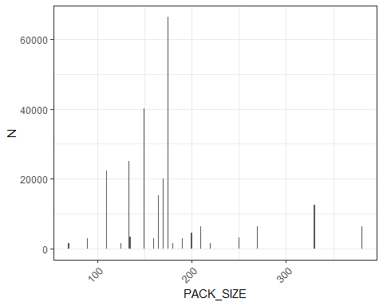

# brand_name; combining the same brands.  
  
transactionData[, BRAND_NAME := gsub("([A-Za-z]+).*", "\\1",PROD_NAME)]  
transactionData[BRAND_NAME == "Red", BRAND_NAME := "RRD"]  
unique(transactionData$BRAND_NAME)

transactionData[BRAND_NAME == "Dorito", BRAND_NAME := "Doritos"]  
transactionData[BRAND_NAME == "Snbts", BRAND_NAME := "Sunbites"]  
transactionData[BRAND_NAME == "Grain", BRAND_NAME := "GrnWves"]  
transactionData[BRAND_NAME == "WW", BRAND_NAME := "Woolworths"]  
transactionData[BRAND_NAME == "NCC", BRAND_NAME := "Natural"]  
transactionData[BRAND_NAME == "Infzns", BRAND_NAME := "Infuzions"]  
transactionData[BRAND_NAME == "Infzns", BRAND_NAME := "Infuzions"]  
transactionData[BRAND_NAME == "SMITH", BRAND_NAME := "SMITHS"]  
# Examining customer Data  
  
str(customerData)

Customer_by_LifeStage = customerData %>% group_by(LIFESTAGE) %>% count(LIFESTAGE)

plot_lifestage = ggplot(data= Customer_by_LifeStage, aes(x=LIFESTAGE, y= n))+  
geom_bar(stat="identity")+  
theme(axis.text.x = element_text(size = 10, angle = 90, hjust = 1))  
plot_lifestage

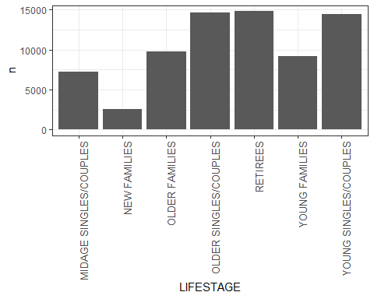

Customer_by_PREMstatus = customerData %>% group_by(PREMIUM_CUSTOMER) %>% count(PREMIUM_CUSTOMER)  
barplot(height = Customer_by_PREMstatus$n, names.arg = Customer_by_PREMstatus$PREMIUM_CUSTOMER)

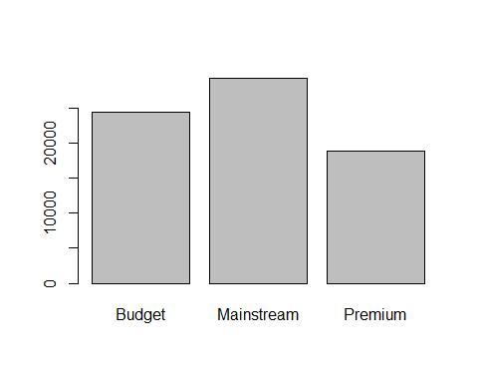

is.null(data)

# Merging data  
data <- merge(transactionData, customerData, all.x = TRUE)  
  
write.csv(data,"QVI_data.csv")  
#PLotting data by premium customer and by life stage  
  
TOtal_sales_lifeStage_premcustomer = aggregate(data$TOT_SALES~data$LIFESTAGE + data$PREMIUM_CUSTOMER, data, sum)  
TOtal_sales_lifeStage_premcustomer$Customerdescription = paste(TOtal_sales_lifeStage_premcustomer$`data$LIFESTAGE`, TOtal_sales_lifeStage_premcustomer$`data$PREMIUM_CUSTOMER`)  
plot = ggplot(data= TOtal_sales_lifeStage_premcustomer, aes(x=Customerdescription, y= TOtal_sales_lifeStage_premcustomer$`data$TOT_SALES`))+  
geom_bar(stat="identity")+  
theme(axis.text.x = element_text(size = 10, angle = 90, hjust = 1))  
plot

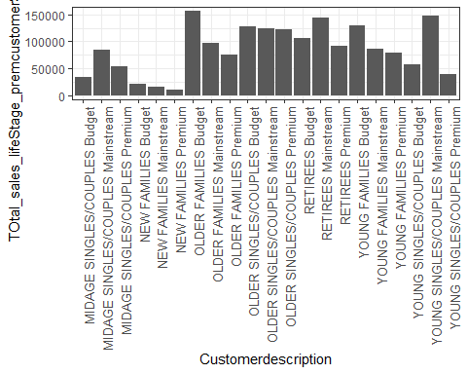

total_quantity = aggregate(data$PROD_QTY~data$LIFESTAGE + data$PREMIUM_CUSTOMER, data, sum)  
total_quantity = as.data.frame(aggregate(data$PROD_QTY~data$LIFESTAGE + data$PREMIUM_CUSTOMER, data, sum))  
total_quantity$Customerdescription = paste(total_quantity$`data$LIFESTAGE`, total_quantity$`data$PREMIUM_CUSTOMER`)  
total_quantity = subset(total_quantity, select = c("Customerdescription", "data$PROD_QTY"))  
total_quantity = merge(total_quantity, TOtal_sales_lifeStage_premcustomer, by = "Customerdescription")  
total_quantity$Average = total_quantity$`data$TOT_SALES`/total_quantity$`data$PROD_QTY`  
  
  
plot_average_sales = ggplot(data= total_quantity, aes(x=Customerdescription, y= total_quantity$Average))+  
geom_bar(stat="identity")+  
theme(axis.text.x = element_text(size = 10, angle = 90, hjust = 1))  
plot_average_sales

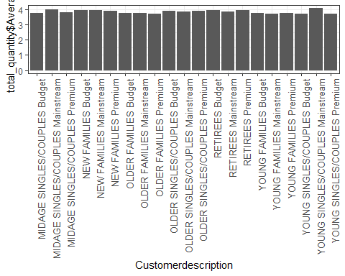

#### t test  
  
t.test(data[PREMIUM_CUSTOMER == "Mainstream" &   
 LIFESTAGE %in% c("YOUNG SINGLES/COUPLES",  
 "MIDAGE SINGLES/COUPLES"), data$TOT_SALES/data$PROD_QTY],data[ PREMIUM_CUSTOMER != "Mainstream" & LIFESTAGE %in% c("YOUNG SINGLES/COUPLES", "MIDAGE SINGLES/COUPLES"), data$TOT_SALES/data$PROD_QTY], alternative = "greater")

## Deep dive into specific customer segments for insights  
library(arules)

library(RColorBrewer)  
main_young = data[PREMIUM_CUSTOMER == "Mainstream" & LIFESTAGE == "YOUNG SINGLES/COUPLES"]  
  
main_young_PROD_NAME = ddply(main_young,c("LYLTY_CARD_NBR"),  
 function(dataframe)paste(dataframe$PROD_NAME,  
 collapse = ","))  
  
main_young_BRAND = ddply(main_young,c("LYLTY_CARD_NBR"),  
 function(dataframe)paste(dataframe$BRAND_NAME,  
 collapse = ","))  
write.csv(main_young_BRAND,"main_young_brand.csv")  
main_young_transaction <- read.transactions("C:/Users/jerem/Documents/R/Quantium/Quantium/main_young_brand.csv", format = 'basket', sep=',')  
itemFrequencyPlot(main_young_transaction,topN = 20,type = "absolute",col=brewer.pal(8,'Pastel2'), main="Frequency Plot", angle = 90)

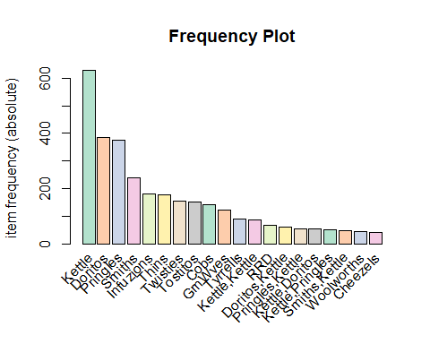

main_young_SIZE = ddply(main_young,c("LYLTY_CARD_NBR"),  
 function(dataframe)paste(dataframe$PACK_SIZE,  
 collapse = ","))  
  
write.csv(main_young_SIZE,"main_young.csv")  
main_young_transaction <- read.transactions("C:/Users/jerem/Documents/R/Quantium/Quantium/main_young.csv", format = 'basket', sep=',')  
itemFrequencyPlot(main_young_transaction,topN = 20,type = "absolute",col=brewer.pal(8,'Pastel2'), main="Frequency Plot")

